ENGADINE WEST PUBLIC SCHOOL
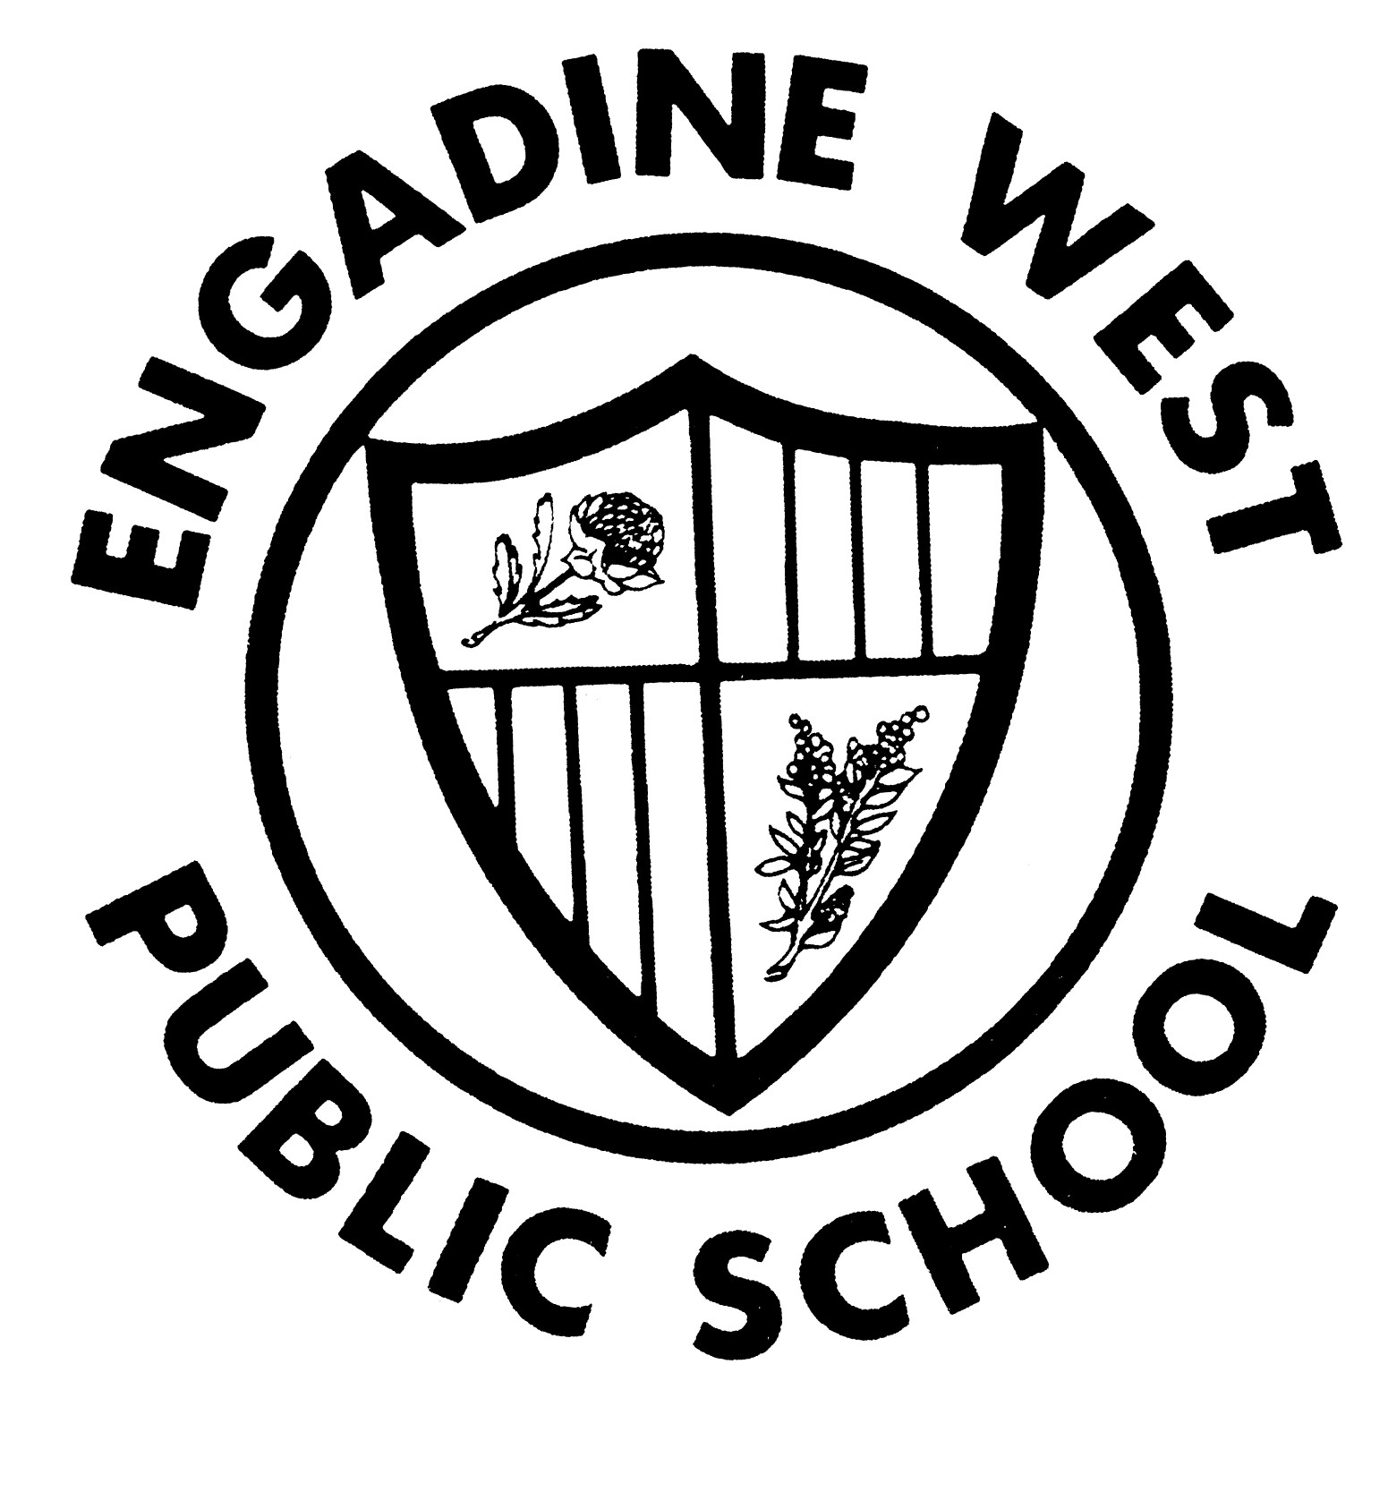
Buckle Avenue, Engadine NSW 2233 Phone: (02) 9520 8134
Email: engadinew-p.school@det.nsw.edu.au Fax: (02) 9520 5314

22 February 2018

Dear parents/carers

2018 International Competitions and Assessments for Schools (ICAS) Students Years 3-6

The gifted and talented team of Engadine West Public School is offering your child the opportunity to participate in The University of New South Wales International Competitions and Assessments for Schools (ICAS) in English and/or mathematics.

ICAS assessments have taken place annually in schools for over 30 years and in 20 countries. Educational Assessment Australia (EAA), who design and deliver the assessments, is the not-for-profit arm of the University of New South Wales.

ICAS:
- gathers performance information through a 30 - 60 minute supervised in-school test
- enables students at all levels of ability to participate; ICAS contains questions designed to specifically explore the abilities of students of all standards - this includes those of both lower and higher levels of achievement
- medals are awarded to the top students in each subject, school year, and state when sufficiently meritorious and the test was sat on the official test date
- achievement certificates are awarded to all students at a range of levels:
- High Distinction to the top 1% of students
- Distinction to the next 10% of students
- Credit to the next 25% of students
- Merit to the next 10% of students
- Participation to all other students
- results are available to parents and students online; these online reports and analyses remain available indefinitely. ICAS reports indicate which questions were answered correctly, compare student performance to that of the other students tested and are highly suitable for inclusion in a student’s portfolio for future tertiary entrance or job opportunities

Engadine West Public School is offering only the English and mathematics tests to avoid ongoing disruption to class routines and our quality learning programs. The tests will commence at 8.30am in the school library; English on Tuesday 31 July 2018 and mathematics on Tuesday 14 August 2018. The test results do not contribute to your child’s school report grades and is not necessarily considered in the selection of an ‘out of area’ high school for Year 6 students. The test material is not necessarily consistent with the new curriculum. To enroll your child in ICAS, please complete the registration form overleaf and return it, with your entry fees, to school by Friday 22 June 2018. (Please note Friday 22 June 2018 will be the final entry day for registering entries for 2018)

Your child can also prepare for ICAS using Practice Online. Practice Online tests are available for English and mathematics. Find out more about Practice Online at www.eaa.unsw.edu.au/practice-online.

Jason Wilkins Sue Roach
Deputy Principal Principal
2018 International Competitions and Assessments for Schools (ICAS)

Registration Form

I give permission for my child/ren:

Child’s Name: _____________________________________________ Class: _________________

Child’s Name: _____________________________________________ Class: _________________

to participate in the following 2018 International Competitions and Assessments for Schools (ICAS)

Name of parent/carer Date

________________________________________________________________________
Signature of parent/carer

Please select the subjects you would like your child to enter:

Subject/Paper | School Years | Official Sitting Date | Entry fee, incl. GST | Fee enclosed
English |  | Tuesday 31 July 2018 | $10
Mathematics |  | Tuesday 14 August 2018 | $10
 |  |  | TOTAL $20

Cash/Cheque Payment:
 Cash/Cheque payment enclosed: $__________________
(cheques are to be made payable to Engadine West Public School)

Online Payment:
 I have made an online payment. My receipt number is: ___________________
Signed: __________________________________________ Date: / /

Please return this form to the school office.

