ENGADINE WEST PUBLIC SCHOOL
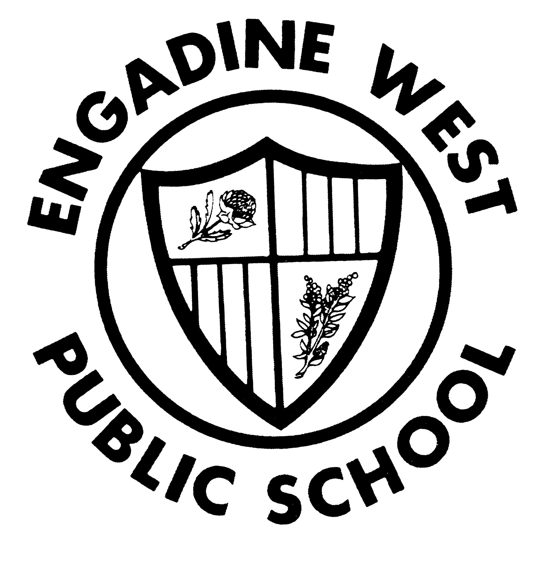

Buckle Avenue, Engadine NSW 2233 Phone: (02) 9520 8134
Email: engadinew-p.school@det.nsw.edu.au Fax: (02) 9520 5314

K-2 Christmas Concert 12.11.10
Dear 1S Parents/Caregivers

As this year comes to a close, all K to 2 classes are busy preparing for a fabulous Christmas Performance. This performance will be held on Friday 3rd December from 12 noon in the school hall. Every child from Kindergarten to Year 2 will have a role in the Christmas Performance. All parents, caregivers, friends and family are welcome to attend.

1S will be the Snowmen in the concert.

Could the children please bring the following things from home by Monday 29th November . We will keep them at school ready for the dress rehearsal and concert.

- White pants (preferably long to cover the legs)
- White top (preferably long sleeve)
- Black shoes (school shoes are ideal these will not be kept at school prior to the performance)
- A bright coloured scarf

We will also be wearing black buttons and a carrot nose made from cardboard, if anyone is able to assist in the making of these it would be greatly appreciated.

Thank you for your support in enabling your child to participate in such a fun event. We are looking forward to a fantastic Christmas extravaganza for 2010 at Engadine West Public School.

Kind Regards
Miss Sideris Mr Royston
Principal

