ENGADINE WEST PUBLIC SCHOOL
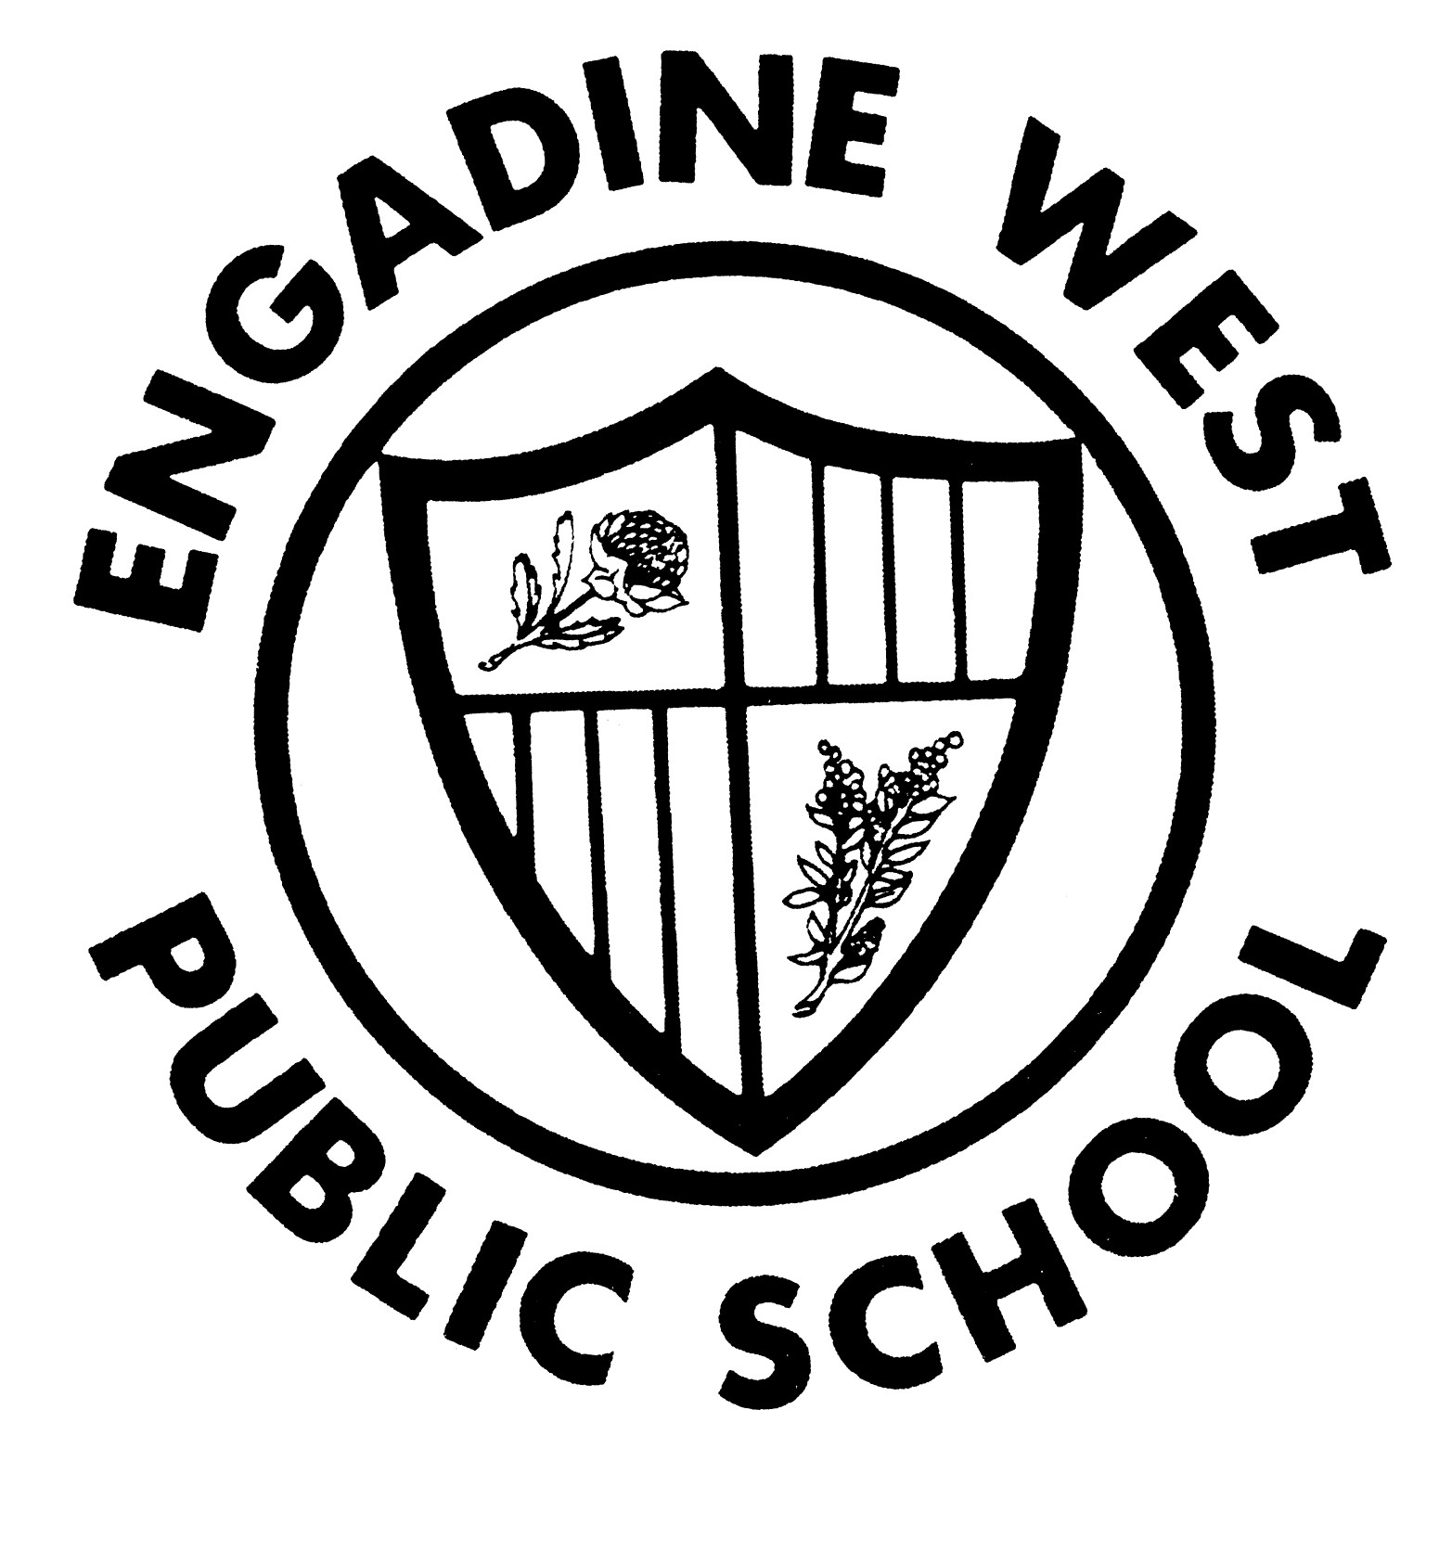

Buckle Avenue, Engadine NSW 2233 Phone: (02) 9520 8134
Email: engadinew-p.school@det.nsw.edu.au Fax: (02) 9520 5314

K-2 Christmas Concert

26.10.10

Dear Parents/Caregivers

As this year comes to a close, all K to 2 classes are busy preparing for a fabulous Christmas Performance. This performance will be held on Friday 3rd December from 12 noon in the school hall. Every child from Kindergarten to Year 2 will have a role in the Christmas Performance. All parents, caregivers, friends and family are welcome to attend.

2A, 2D and some 2M girls are dancing in the concert.

Could the children please bring the following things from home by Wednesday 31st November . We will keep them at school ready for the dress rehearsal and concert.

- black tights
- white singlet top

The girls will also be wearing a Christmas inspired tutu. Some very kind and generous 2A mums have offered their time to make the tutus, which do not involve any sewing. If you are also able to assist, they will be having a working bee on Thursday 18th November at 9.30am at the school. Your time and help will be very much appreciated.

To cover the cost of materials, there will be a note to advise the cost of the tutu per child, but we will be endeavouring to keep this minimal.
Thank you for your support in enabling your child to participate in such a fun event. We are looking forward to a fantastic Christmas extravaganza for 2010 at Engadine West Public School.

Kind Regards
Mrs Payne Mr Royston
Principal

