BUSHFIRE

NATURE OF HAZARD

Every year New South Wales experiences a large number of bushfires, usually caused by lightning or humans. Several can and do occur in the Sutherland Shire from time to time. Most are not disasters, however, if not quickly detected and extinguished, bushfires can become an emergency which threatens both life and property.

RISK FACTORS

Bushfire prone areas are those that can support a bushfire or are likely to be subject to bushfire attack. These are generally areas consisting of or close to bushfire hazards such as forest or grasslands. Engadine West Public School is located close to the Royal National Park and is therefore in an area subject to bushfire attack. Engadine West PS is at most risk of bushfire during the spring and summer months.

PREVENTION STRATEGIES

Before the bushfire season:
- Conduct evacuation drills
- Liaise with emergency services about emergency procedures
- Discuss with emergency services other issues where appropriate e.g. back burning in bush area adjacent to the workplace
- Arrange for contractors to clear gutter of dry leaves and other debris
- Monitor the RFS website, phone the Emergency Centre at Heathcote or listen to the local radio station for bushfire or weather warnings and advice during the time of year when the risk of bushfire is highest
- Outline bushfire response procedures at a staff meeting in September each year.

RESPONSE

General Points …

In the event of a bushfire:
- Contact Fire Brigade on 000. Do not assume that the fire has been reported
- Check that taps are working and fill available containers with water
- Leave sprinklers on, where possible
- Bring hoses and tap fittings indoors
- Remove flammable items from windows
- Stay clear of windows
- Listen to the local radio station for information and advice.

If you decide to … STAY!
If the organised movement of students to Anzac Oval is not practical, the following procedures should be followed:

The lockdown bell will sound.

The Communications Officer will inform the Fire Control centre by phone of any action being taken.

The Chief Warden (Principal) will …
- Direct students and staff to remain within their home class. Rolls will be called when inside and reports will be made to the Chief Warden (Principal). A battery radio will be tuned to 2SSR FM (99.7) for emergency information.
- If time allows, block gutters and fill them with water and hose down the building
- All windows and doors should be closed and blinds drawn (if fitted) and the base of doors should be covered to prevent smoke entry
- Air conditioning should be turned off
- Students should be assembled away from the part of the building which will be initially exposed to the fire, in accordance with established evacuation procedures
- When the fire has passed, the students and staff should leave the building in an orderly manner by the nearest, safest exit and assemble on the top grass area if this is away from the initial exposure area
- A roll call should be conducted.
- Attempts may then be made to extinguish parts of the buildings which have been ignited, provided personal safety is not endangered

Note 1: Bushfires can turn around. The safe area needs to be away from trees and other items capable of sustaining a flame.
Note 2: The special needs of the students who suffer breathing conditions, eg. asthma, will need to be carefully managed. (see Asthma Management Plans)

If you decide to … GO!
In the case of bushfire, evacuation of students and staff should ideally take place under the direction of the incident commander of the NSW Fire Brigades, Rural Fire Service or NSW Police. However, if it is apparent that the lives of students and staff will be endangered unless they are evacuated immediately, and the workplace manager is unable to contact the appropriate emergency services, the workplace manager should make immediate arrangements to evacuate to Anzac Oval. In such cases, transport arrangements as outlined in the workplace emergency evacuation procedures will be implemented in consultation with local police. Students will not be permitted to proceed unsupervised to their homes because of possible exposure to the threat of bushfires.
Go Early Re-Location – If the RFS bushfire rating reaches EXTREME or CATESTROPHIC and bushfires are known to be burning within 100 kms, then Go Early should be considered.

The Evacuation
The evacuation emergency bell will sound. Students and teachers will as per our evacuation procedures (see appendix A) with rolls, medications, mobile phones, and other listed items.

If it is unlikely that a bus evacuation from Engadine West PS will be viable due to its isolation and the tight streets the school will need to be evacuated by foot with each student remaining with their class teacher and each class moving with the whole school group to Anzac Oval. Senior classes would take up positions at the front and rear of the group while juniors eg. Kinder and Year 1 would walk in the middle. Due to possible exposure to the threat of bush fires, students will not be permitted to proceed unsupervised to their homes. Parents only will be permitted to collect and sign out their own children but will not be allowed to sign out other children. The group will travel with class rolls, mobile phones, puffers and first aid kits. Disabled students will be moved by motor vehicle.

Evacuation Route

Evacuation Route One (see map below)
All evacuation points should exit the school from the Woronora Road Gates
- Assemble at evacuation points as per the school’s evacuation plan
- Move through the school and assemble at the Woronora Rd Gates
- Cross at the Woronora Rd crossing
- Turn right and walk 20m towards the Anzac shops
- Turn left and walk down the lane adjacent to the Anzac shops
- Cross the Engadine Leisure Centre Carpark and enter Anzac Oval
- Assemble at the cricket nets adjacent to Anzac Road

MAP ->
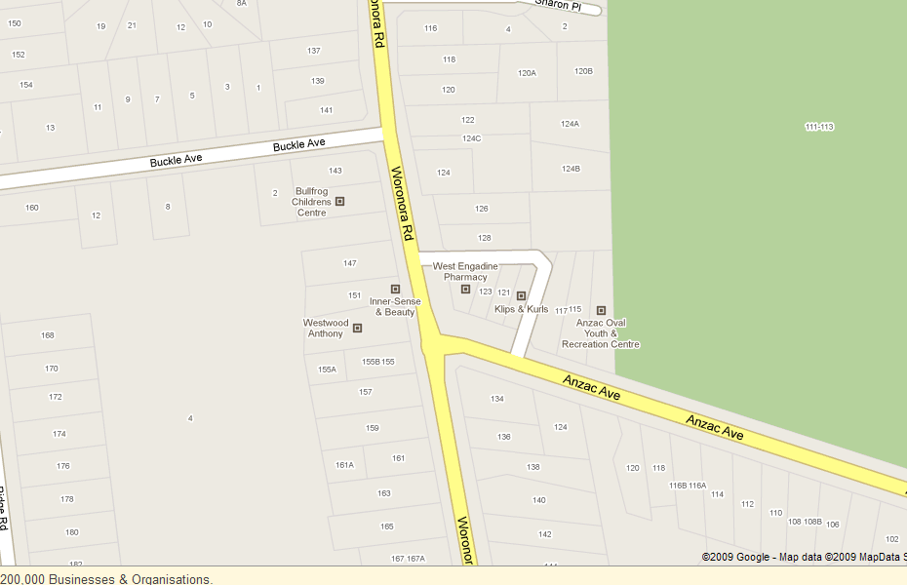

N

Go Early Re-Location Plan
If the RFS bushfire rating reaches EXTREME or CATESTROPHIC and bushfires are known to be burning within 100 kms, the chief fire warden should consider the Go Early Plan.
This plan entails the orderly relocation of the school and its population to Anzac Oval in a timely fashion.
Ideally, the chief fire warden should obtain information on the current fire situation and discuss the possible re-location with Miranda Office and the Heathcote Emergency Centre.
The Go Early Plan is designed to contain possible student panic and provide a safer venue while still providing appropriate learning activities.
Whenever practical, parents should be alerted to the possibility of the Go Early plan being activated. Notices will also be placed on each school building, noting the evacuation details.
The group will travel with class rolls, mobile phones, puffers, first aid kits and any educational resources that the teachers feel will be practical in the circumstances.
The duty officer at Sutherland police station, the chief fire officer at Heathcote Emergency Centre and the School Education Director must be notified of the re-location.

RECOVERY ACTIONS

Implement the workplace emergency management plan recovery strategy. For example:
- Decide when to re-open the workplace, in consultation with local emergency services
- Normally, the NSW Fire Brigade will check that utilities (water, electricity and natural gas) are either safe to use or are disconnected before they leave the site. Do not attempt to turn on utilities yourself
- Implement procedures to resume workplace activities, which include providing counselling and support to those affected by the incident
- Where property has been damaged, liaise with the emergency services and Asset Management
- Review the emergency management plan.

Contact
Sutherland Hospital 9540 7111
Emergency 000
Dr Brookes’ Surgery 9548 6769
Sutherland Council 9710 0333

FURTHER INFORMATION

- NSW Fire Brigades
- NSW Rural Fire Service
- Emergency Management Australia

