ENGADINE WEST PUBLIC SCHOOL
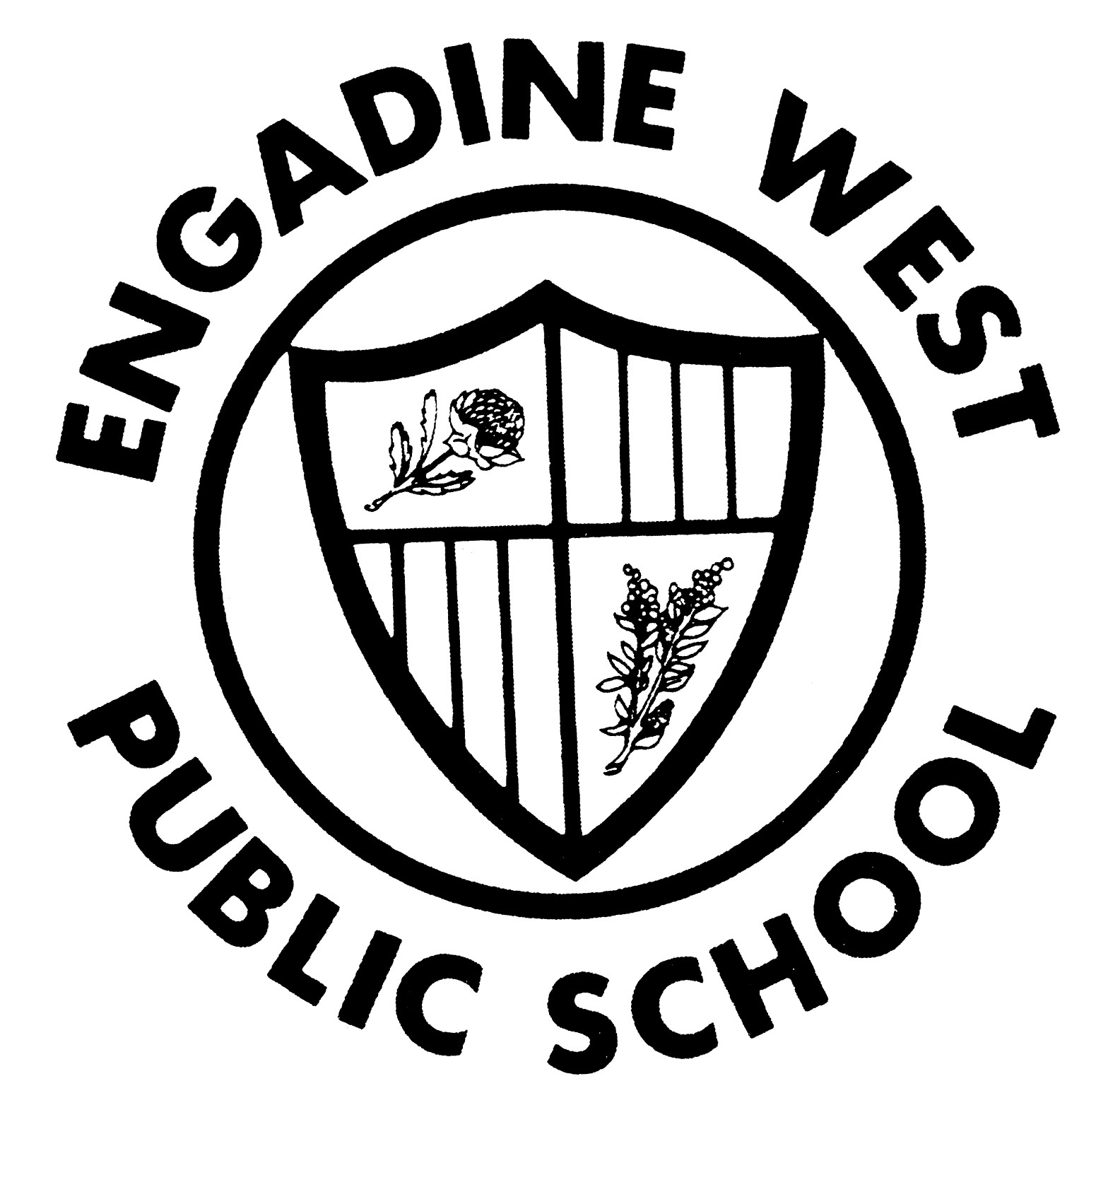

02 February 2016

Dear Parents

YEAR 5 CAMP 2016 – MYUNA BAY SPORT AND RECREATION CENTRE

As you are aware, Year 5 students will attend the Myuna Bay Sport and Recreation Camp from Monday 7 March 2016 until Wednesday 9 March 2016 (Week 7, Term 1).

The cost of camp this year is $330.00, which includes bus transport and all meals and activities while the children are at camp. Please be aware both the cost of bus transport and Myuna Bay fees have increased slightly this year requiring a slight increase in the total cost.

Thank you to those families who have paid the $50.00 deposit, the balance due is $280.00. Final payment should be made by Friday 26 February 2016. If you require a payment plan please do not hesitate to contact the school to discuss this.

Myuna Bay Sport and Recreation camp require all medical forms (including dietary requirements) to be completed online prior to attending the camp. You can complete this form by visiting the web address below. You will also need the booking number, start date and venue which are also listed below. This is a compulsory document and MUST be completed by all students no later than Friday 12 February 2016.

https://sportandrecreation.nsw.gov.au/facilities/medicalandconsentform

Booking number: 464707
Booking start date: Monday 7th March 2016
Venue: Myuna Bay

If you have any questions or concerns about the Year 5 camp, please do not hesitate to contact us at school.

Year 6 Teachers Garry Royston
Principal

ENGADINE WEST PUBLIC SCHOOL
MYUNA BAY SPORT & RECREATION CAMP

Child’s Name: _____________________________________ Class: _______________

Card Type:  Bankcard  Visa  Mastercard
Card Number: _ _ _ _ _ _ _ _ _ _ _ _ _ _ _ _
Card Holder’s Name: Expiry Date:
Card Holder’s Signature: Amount:
Card Holder’s Contact No:

