ENGADINE WEST PUBLIC SCHOOL
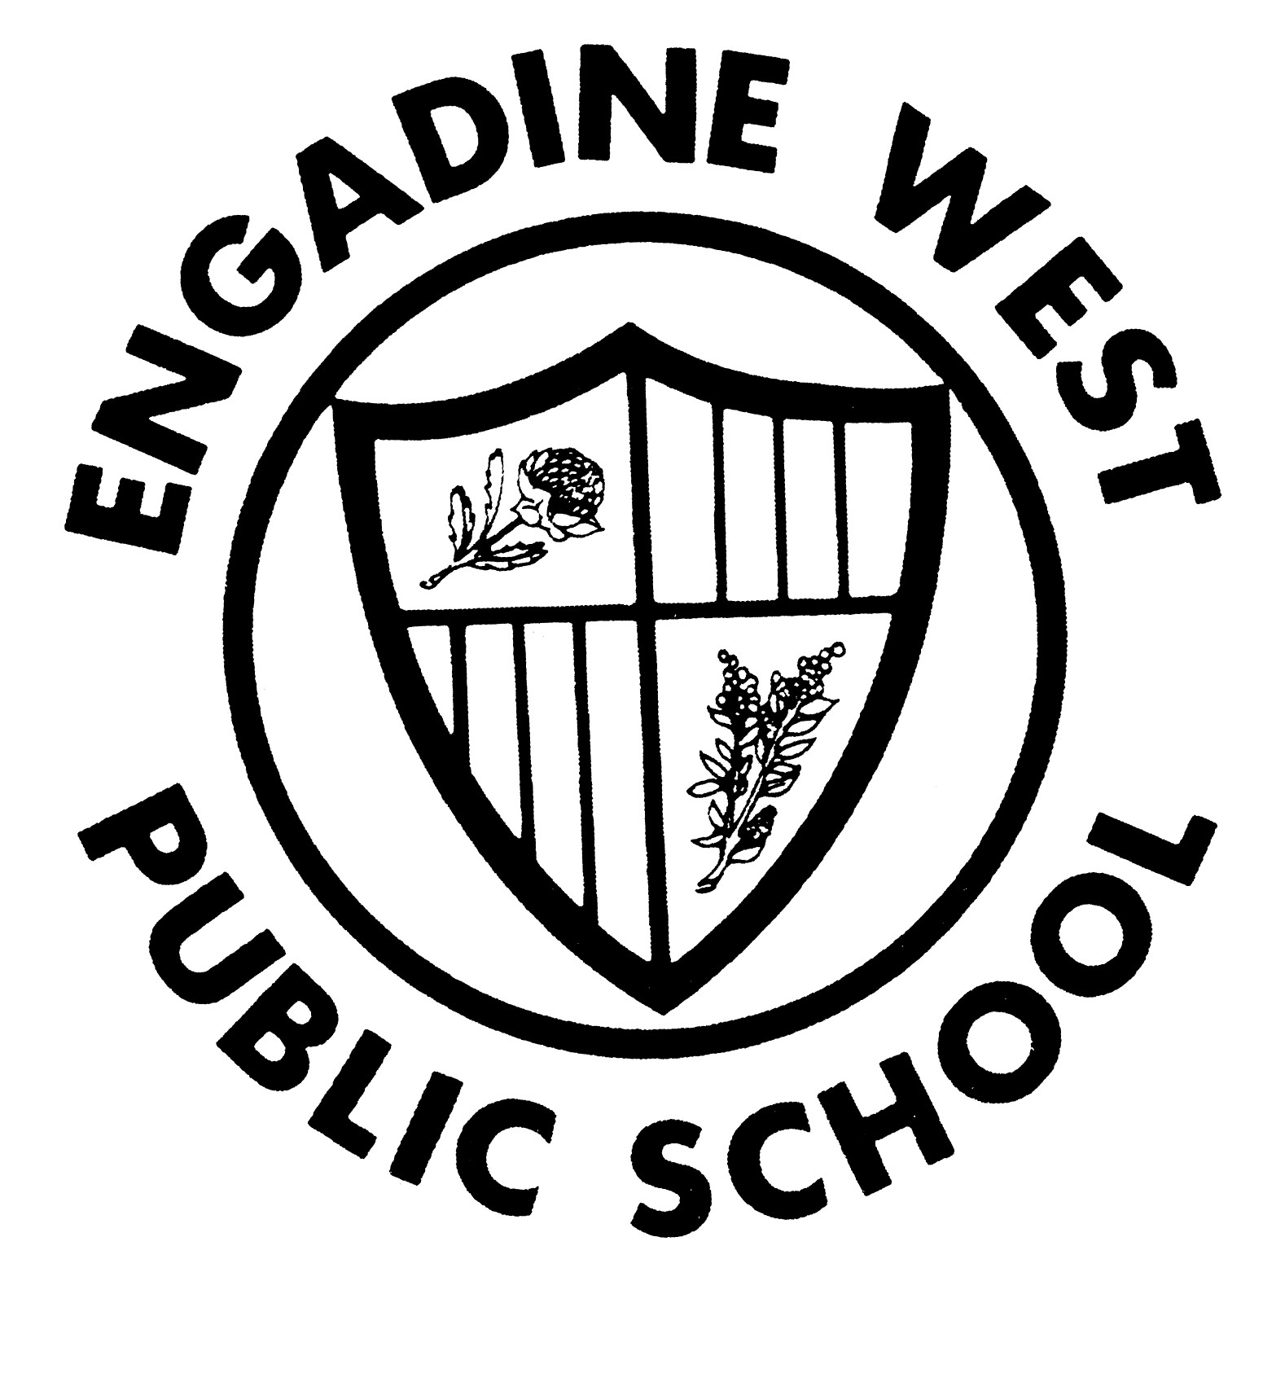

Buckle Avenue, Engadine NSW 2233 Phone: (02) 9520 8134
Email: engadinew-p.school@det.nsw.edu.au Fax: (02) 9520 5314

2016 International Competitions and Assessments for Schools (ICAS) Students Years 3-6

Dear Parent
Engadine West Public School is offering your child the opportunity to participate in The University of New South Wales International Competitions and Assessments for Schools (ICAS) in English and/or Mathematics.
ICAS assessments have taken place annually in schools for over thirty years and in 20 countries. Educational Assessment Australia (EAA), who design and deliver the assessments, is the not-for-profit arm of the University of New South Wales.
ICAS:
- gathers performance information through a 30–60 minute supervised in-school test
- enables students at all levels of ability to participate; ICAS contains questions designed to specifically explore the abilities of students of all standards – this includes those of both lower and higher levels of achievement
- medals are awarded to the top students in each subject in each school year in each state when sufficiently meritorious and the test was sat on the official test date
- achievement certificates are awarded to all students at a range of levels:
- High Distinction to the top 1% of students
- Distinction to the next 10% of students
- Credit to the next 25% of students
- Merit to the next 10% of students
- Participation to all other students
- results are available to parents and students online; these online reports and analyses remain available indefinitely. ICAS reports indicate which questions were answered correctly, compare student performance to that of the other students tested and are highly suitable for inclusion in a student’s portfolio for future tertiary entrance or job opportunities

Engadine West P.S. is offering only the English and Mathematics tests to avoid ongoing disruption to class routines and our quality learning programs. The tests will commence at 8.30am in the school library on Monday 27 July and Tuesday 16 August. The test results do not contribute to your child’s school report grades and is not necessarily considered in the selection of an out of area high school for Year 6 students. The test material is not necessarily consistent with the new curriculum. To enroll your child in ICAS, please complete the registration form overleaf and return it, with your entry fees, to school by Friday 10 June.

(Please note Friday 10 June will be the final entry day for registering entries for 2016)

Your child can also prepare for ICAS using Practice Online. Practice Online tests are available for English, Mathematics and Science. Find out more about Practice Online at www.eaa.unsw.edu.au/practice-online.

Ross Edwards Garry Royston
Deputy Principal Principal
13.5.16

2016 International Competitions and Assessments for Schools (ICAS)

Registration Form

Please return this form to your child’s school

I give permission for my child of
Child’s name Class

to participate in the following 2016 International Competitions and Assessments for Schools (ICAS):

Please select the subjects you would like your child to enter:

Subject/Paper | School Years | Official Sitting Date | Entry fee, incl. GST | Fee enclosed
English | 2 – 12 | 27 July 2015 | $9
Mathematics | 2 – 12 | 16 August 2015 | $9
 |  |  | TOTAL

Please find enclosed ____________________total entry fee.
Amount

Name of Parent/Guardian Date

________________________________________________________________________
Signature of Parent/Guardian

Engadine West Public School

EFTPOS PAYMENT FORM (ONLY FOR PAYMENTS OVER $10 PLEASE)

Date: ____/____/ ____

Student Name | Class | Purchase | Amount
 |  | Total Amount Paid

Credit Card Details
Card Type:  Bankcard  Visa  Mastercard
Card Number: __ __ __ __ __ __ __ __ __ __ __ __ __ __ __ __
Card Holder’s Name: Expiry Date:
Card Holder’s Signature:
Card Holder’s contact number

